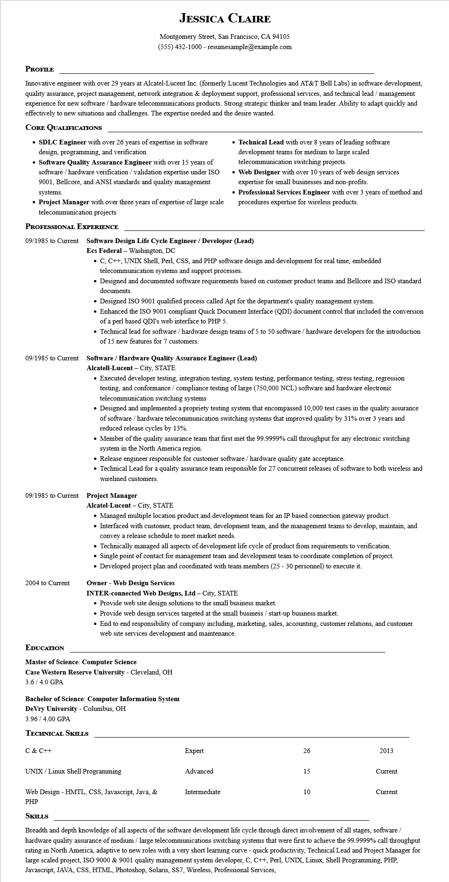
JESSICA CLAIRE
Montgomery Street, San Francisco, CA 94105
(555) 432-1000 - resumesample@example.com
PROFILE
Innovative engineer with over 29 years at Alcatel-Lucent Inc. (formerly Lucent Technologies and AT&T Bell Labs) in software development, quality assurance, project management, network integration & deployment support, professional services, and technical lead/management experience for new software/hardware telecommunications products. Strong strategic thinker and team leader. Ability to adapt quickly and effectively to new situations and challenges. The expertise needed and the desire wanted.
CORE QUALIFICATIONS
SDLC Engineer with over 26 years of expertise in software design, programming, and verification
• Software Quality Assurance Engineer with over 15 years of software/hardware verification/validation expertise under ISO 9001, Bellcore, and ANSI standards and quality management systems.
• Project Manager with over three years of expertise of large scale telecommunication projects
PROFESSIONAL EXPERIENCE
• Technical Lead with over 8 years of leading software development teams for medium to large scaled telecommunication switching projects.
• Web Designer with over 10 years of web design services expertise for small businesses and non-profits.
• Professional Services Engineer with over 3 years of method and procedures expertise for wireless products.
09/1985 to Current Software Design Life Cycle Engineer/Developer (Lead) Ecs Federal - Washington, DC
• C, C++, UNIX Shell, Perl, CSS, and PHP software design and development for real time, embedded telecommunication systems and support processes.
• Designed and documented software requirements based on customer product teams and Bellcore and ISO standard documents.
• Designed ISO 9001 qualified process called Apt for the department's quality management system.
• Enhanced the ISO 9001 compliant Quick Document Interface (QDI) document control that included the conversion of a perl based QDI's web interface to PHP 5.
• Technical lead for software/hardware design teams of 5 to 50 software/hardware developers for the introduction of 15 new features for 7 customers.
09/1985 to Current Software/Hardware Quality Assurance Engineer (Lead)
Alcatell-Lucent - City, STATE
• Executed developer testing, integration testing, system testing, performance testing, stress testing, regression testing, and conformance/compliance testing of large (750,000 NCL) software and hardware electronic telecommunication switching systems
• Designed and implemented a propriety testing system that encompassed 10,000 test cases in the quality assurance of software/hardware telecommunication switching systems that improved quality by 31% over 3 years and reduced release cycles by 13%.
• Member of the quality assurance team that first met the 99.9999% call throughput for any electronic switching system in the North America region.
• Release engineer responsible for customer software/hardware quality gate acceptance.
• Technical Lead for a quality assurance team responsible for 27 concurrent releases of software to both wireless and wirelined customers.
09/1985 to Current Project Manager
2004 to Current
Alcatel-Lucent - City, STATE
• Managed multiple location product and development team for an IP based connection gateway product.
• Interfaced with customer, product team, development team, and the management teams to develop, maintain, and convey a release schedule to meet market needs.
• Technically managed all aspects of development life cycle of product from requirements to verification.
• Single point of contact for management team and development team to coordinate completion of project.
• Developed project plan and coordinated with team members (25 - 30 personnel) to execute it.
Owner - Web Design Services
INTER-connected Web Designs, Ltd - City, STATE
• Provide web site design solutions to the small business market.
• Provide web design services targeted at the small business / start-up business market.
• End to end responsibility of company including, marketing, sales, accounting, customer relations, and customer web site services development and maintenance.
EDUCATION
Master of Science: Computer Science
Case Western Reserve University - Cleveland, OH 3.6/4.0 GPA
Bachelor of Science: Computer Information System
DeVry University - Columbus, OH
3.96/4.00 GPA
TECHNICAL SKILLS
C & C++
Expert
26
2013
UNIX/Linux Shell Programming
Advanced
15
Current
Web Design - HMTL, CSS, Javascript, Java, &
Intermediate
10
Current
PHP
SKILLS
Breadth and depth knowledge of all aspects of the software development life cycle through direct involvement of all stages, software/ hardware quality assurance of medium/large telecommunications switching systems that were first to achieve the 99.9999% call throughput rating in North America, adaptive to new roles with a very short learning curve - quick productivity, Technical Lead and Project Manager for large scaled project, ISO 9000 & 9001 quality management system developer, C, C++, Perl, UNIX, Linux, Shell Programming, PHP, Javascript, JAVA, CSS, HTML, Photoshop, Solaris, SS7, Wireless, Professional Services,

